Chip back potential is the level which bulk silicon is maintained by on-chip connection, or it is the level to which the chip back must be connected when specifically stated below. If no potential is given the chip back should be isolated.

PAD FUNCTIONS:

- SOURCE
- DRAIN
- GATE
- DIODE

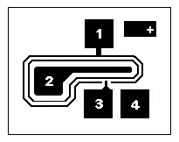
.022”
.019”
MASK
REF
SPI SD210-1B

2
4

Top Material: Al
Backside Material: Au
Bond Pad Size: .0037” X .0037”
Backside Potential:
Mask Ref: SD210

APPROVED BY: DK DIE SIZE .019” X .021” DATE: 2/7/17
MFG: TELEDYNE / TOPAZ THICKNESS .011” P/N: SD211
DG 10.1.2

Rev B, 7/19/02

